Assignment 1
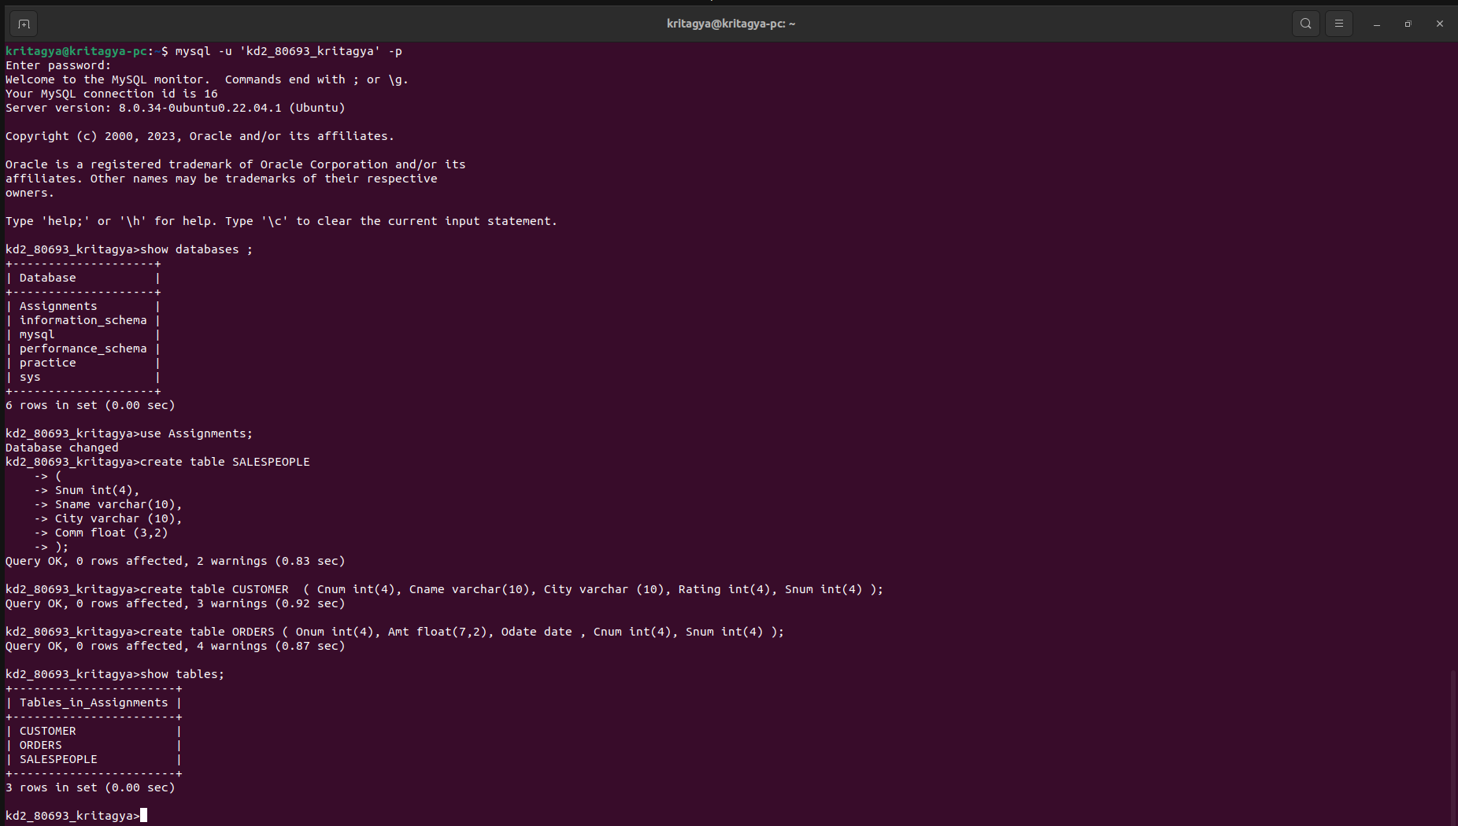
TABLE CREATION

INSERTING VALUES



ASSIGNMENT 2

1.) Primary Key for Customers table is Cnum

2.) Comm (commision ) is the 4th column of customers table

3.) Another word for ROW is TUPLE and another word for COLUMN is ATTRIBUTE .

4.) Its not possible to see the first five rows of the table in MySQL because in MySQL there is no column of row number and data is stored randomly in Hard Disk to make the instert method very fast , and when using select key the data is shown based on the address which come fast

ASSIGNMENT 3

1.) Yes ANSI recognise the DATE data type of MySQL , the default format is based on ANSI Standards.

2.) DML subdivision of SQL is used to insert values in the tables by using the INSERT statement.
Other DML statements are Delete and Update.

ASSIGNMENT 4
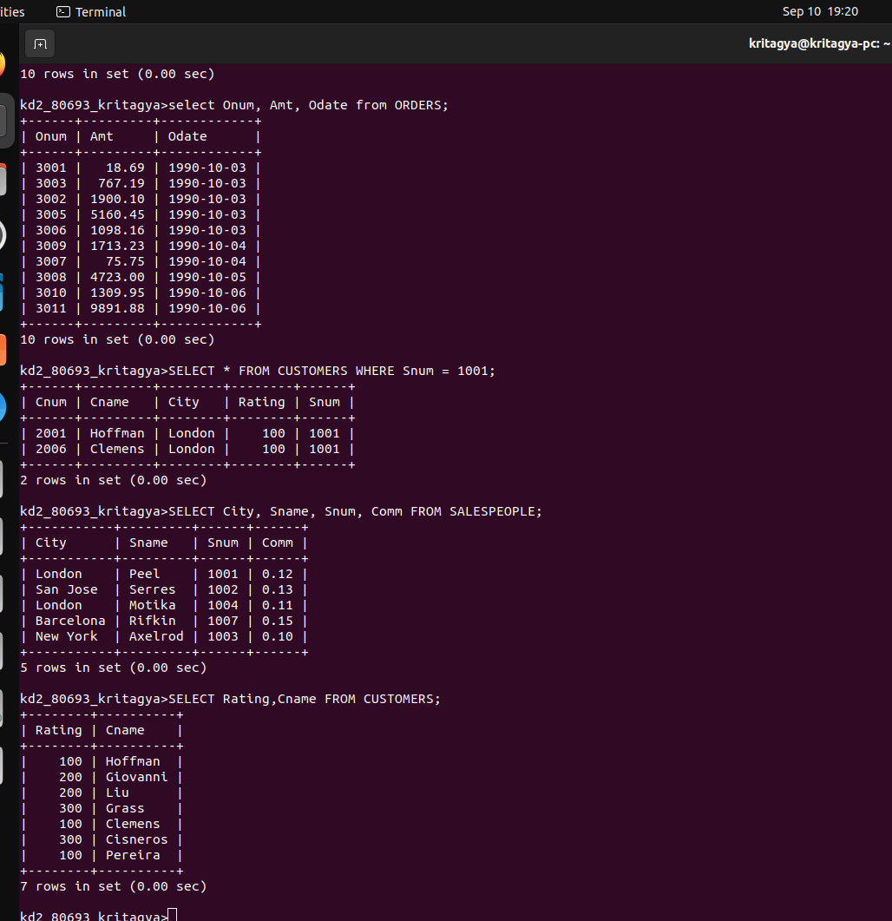

ASSIGNMENT 5

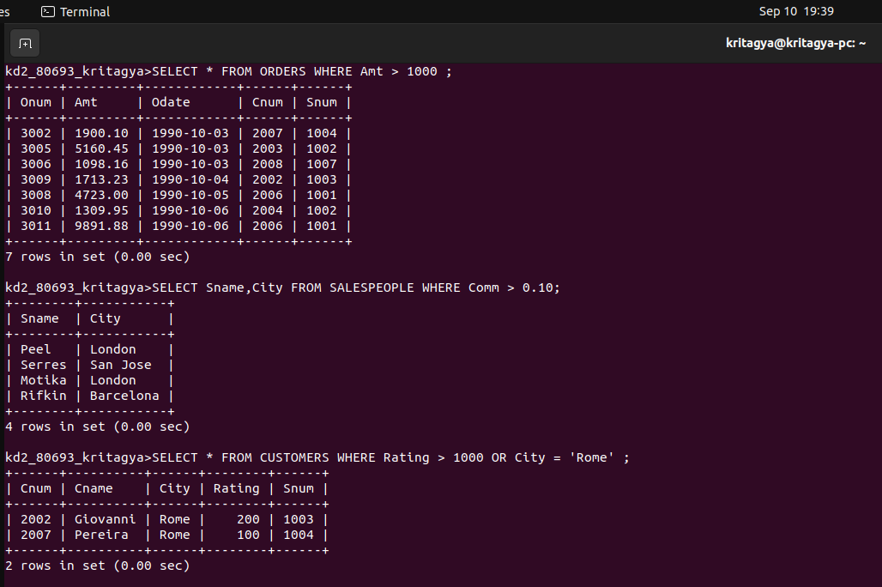

4.)The output is all the columns from order table where the amount is less than 1000 or values not included in odate = 03 oct 1990 and Cnum greater than 2003

5.) The output will be all columns from order table which does not include in the following condition that is ( either odate = 03 oct 1990 or snum is greater than 1006 ) and amount >=1500.

6.) This is a trick question , where clause is not altering any values here because of OR operator sor the simpler way will be - :

SELECT * FROM SALESPEOPLE ;

aslo added SS for last 3 questions if required

